Day 11 - 30th July 2026

Task 1:
What is an Actuator in Spring boot?
Spring boot actuator is a module that helps you monitor, manage and inspect a running spring boot application in production.
It provides ready to use endpoints that expose information about the application’s health, metrics, configuration, beans, environment, and more
<dependency>
<groupId>org.springframework.boot</groupId>
<artifactId>spring-boot-starter-actuator</artifactId>
</dependency>

Task 2:
Advantages of Actuator
- Health Monitoring
- Performance Metrics
- Production Readiness
- Easy Troubleshooting
- Application monitoring Integration
- Configuration visibility
- Bean Inspection
- Dynamic log management
- Minimal development effort
- Improved system reliability

Task 3:
What are the commonly used Actuator end points?
/actuator/health : displays the health status of the application
/actuator/info : provides custom information about the application
/actuator/metrics: show application metrics such as CPU usage, memory usage, request count and JVM statistics
/actuator/env : display environment properties & configurations values
/actuator/beans : list all spring beans loaded in the application context
/actuator/mapping : show all http requests mapped in the application
/actuators/logging : allows viewing & changing log levels at runtime.

Task 4:
Create a Small demo of Actuator to know the functionality
Add a starter actual dependency
<dependency>
<groupId>org.springframework.boot</groupId>
<artifactId>spring-boot-starter-actuator</artifactId>
</dependency>

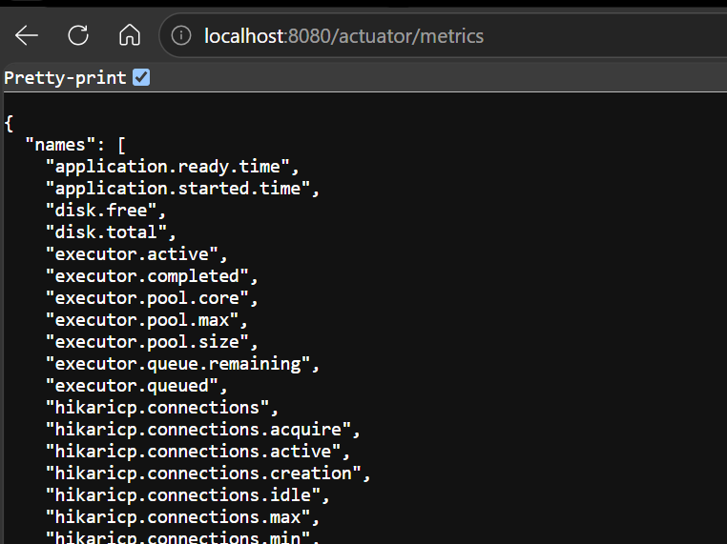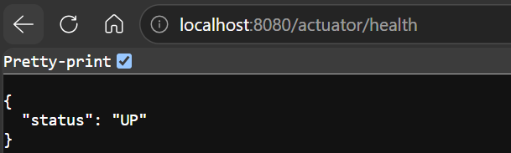
Task 5:
What is Spring Security Architecture?
Spring Security Architecture is the framework structure that provides authentication, authorization and protection against common security threats in spring applications.
It works by intercepting incoming requests through a chain of security filters, authenticating users, and determining whether they have permission to access a resource.

Task 6:
What are the core components of Spring security architecture
- Security Filter Chain
It is responsible for Authentication, Authorization, Session Management, CSRF protection, Exception handling etc.
- Authentication:
The authentication object represents the currently logged in user and their credentials.
- Authentication Manager:
it is responsible for processing authentication requests
- Authentication Provider:
Authentication provider performs the actual validation of user credentials
- UserDetailsService:
loads user information from a database.
- UserDetails:
The userdetail object contains the authenticated user information
- PasswordEncoder:
The password encoders encrypts and verifies the password
- Security Context:
The security context stores authentication information of the currently logged in user
- Authorization:
Authorization determines what resources a user can access after successful authentication.

Task 7:
Can you create a diagrammatic representation of Spring Security architecture
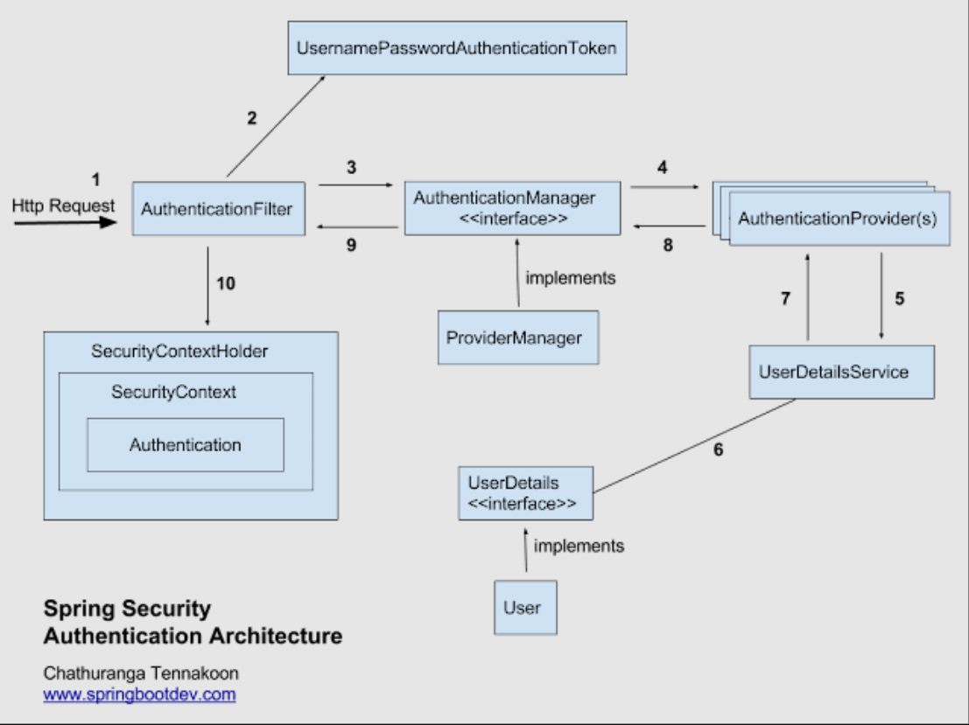

Task 8:
What is a Security filter chain? Give example code
A security filter is the core component of spring security that intercepts every incoming HTTP request and applies security checks before request reaches the application.

Task 9:
What is an Authentication Manager? Give example code
Authentication Manage is a core security component responsible for authenticating a user’s credentials
When a user attempts to login, the authentication manager receives the authentication request and delegates it to AuthenticationProvider Implementation to verify the user identity.

Task 10:
What are Authentication Proividers? Give example and code
An authentication provider is a spring security component responsible for performing the actual authentication logic.
It receives the user credentials from Authentication Manager and validates them, and returns authenticated object if the credentials are correct.

Task 11:
What is USerDeatilsService? Give example
UserDetailsService is a core interface in spring security used to load user specific information during the authentication process.
It loads the user data from the database.
Retrieves the username & password, roles & RBAC from the database for validation purpose.

Task 12:
What is Password encoder? Give example
Password encoder is a Spring security interface used to encrypt passwords before storing them.
Instead of storing plain-text passwords, Spring Security stores encoded passwords making the application more secure.

Task 13:
What is SecurityContextHeader?
SecurityContextHolder is a core spring security class that store and provides access to the current user’s security information throughout the request lifecycle. It holds the securityContext, which contains the authenticated user’s Authentication Object.

Task 14:
Finally give the security Architecture internal functionality? How actually it works internally… step by step if you can explain
1. Client Request
↓
2. Security Filter Chain
↓
3. UsernamePasswordAuthenticationFilter
↓
4. AuthenticationManager
↓
5. AuthenticationProvider
↓
6. UserDetailsService
↓
7. Database
↓
8. PasswordEncoder
↓
9. Authentication Success
↓
10. SecurityContextHolder
↓
11. Authorization Check
↓
12. Controller
↓
13. Response to Client

Spring Security Internal Flow
- Client Request → User sends a request (login or API call) to the application.
- Security Filter Chain → Intercepts the request and applies security checks.
- UsernamePasswordAuthenticationFilter → Extracts username and password from the request.
- AuthenticationManager → Receives the credentials and coordinates authentication.
- AuthenticationProvider → Performs the actual credential validation.
- UserDetailsService → Loads user information from the database.
- Database → Returns stored user details, password, and roles.
- PasswordEncoder → Compares the entered password with the stored encrypted password.
- Authentication Object Creation → Creates an authenticated user object if validation succeeds.
- SecurityContextHolder → Stores authenticated user details for the current request.
- Authorization Check → Verifies whether the user has the required role/permission.
- Controller Execution → Allows the request to reach the target controller if authorized.
- Response → Sends the result back to the client.
- Subsequent Requests → Authentication is retrieved from Session or JWT token instead of logging in again.

Task 15:
What is Thymeleaf? Explain? Why is it used?
Thymeleaf is a modern java based server side template engine used for building dynamic web pages in Spring and Spring boot applications.
It allows the developers to create HTML pages and dynamically display data from the backend without writing java code inside the HTML
It mainly used for rendering user interfaces, displaying dynamic content and handling forms in web application.

Task 16:
Create a demo on thymeleaf .
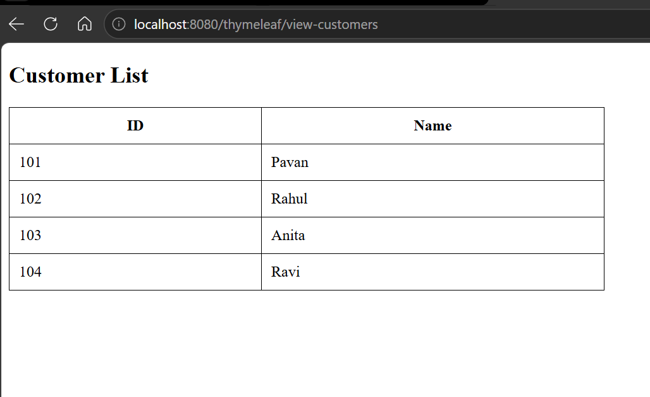
package com.dbexample.controller;
import com.dbexample.service.CustomerService;
import org.springframework.stereotype.Controller;
import org.springframework.ui.Model;
import org.springframework.web.bind.annotation.GetMapping;
import org.springframework.web.bind.annotation.RequestMapping;
@Controller
@RequestMapping("/thymeleaf")
public class CustomerViewController {
private final CustomerService service;
public CustomerViewController(CustomerService service) {
this.service = service;
}
@GetMapping("/view-customers")
public String viewCustomers(Model model) throws Exception {
model.addAttribute(
"customers",
service.getCustomers()
);
return "customers";
}
}

<!DOCTYPE html>
<html xmlns:th="http://www.thymeleaf.org">
<head>
<title>Customers</title>
<style>
table{
border-collapse: collapse;
width:50%;
}
th,td{
border:1px solid black;
padding:10px;
}
</style>
</head>
<body>
<h2>Customer List</h2>
<table>
<tr>
<th>ID</th>
<th>Name</th>
</tr>
<tr th:each="customer : ${customers}">
<td th:text="${customer.id}"></td>
<td th:text="${customer.name}"></td>
</tr>
</table>
</body>
</html>

<dependency>
<groupId>org.springframework.boot</groupId>
<artifactId>spring-boot-starter-thymeleaf</artifactId>
</dependency>

Task 17:
What do you think are the advantages of using thymeleaf?
- Seamless integration with the spring boot
- Natural HTML Template
- Easy Data Binding
- Better readability and maintainability
- Built in form handling
- Spring Security Integration
- Reduce Boilerplate code

Task 18:
What is Caching in Springboot?
Caching is a technique used to store frequently accessed data in temporary memory (Cache) so that future requests can be served faster without repeatedly fetching data from the database expensive computations
Spring Boot Caching Annotations
@EnableCaching: Enables caching in application.
@Cachable: Store method results in cache
@CachePut: update the cache whenever the method executes
@CacheEvict: removes the data from cache

Task 19:
What are the features of caching in SpringBoot?
Caching in spring boot provides several powerful features that help improve application performance by storing frequently accessed data and reducing repetitive database or API calls.
- Easy Enablement
- Annotation Based Caching
- Automatic data retrieval
- Multiple cache support
- Cache update support
- Cache Eviction
- Key-Based Caching
- Reduced database load
- Improved application performance
- Scalability performance
- Transparent integration
- Support for distributed caching

Task 20:
What are the types of Caching ?explain each type.
1. In-Memory Cache (Local Cache)
Data is stored in the application's memory (RAM).
2. Distributed Cache
Data is stored in a separate cache server and shared across multiple application instances.
3. Database Cache
Data is cached at the database level.
4. HTTP/Browser Cache
Responses are stored in the browser or proxy server.
5. Application-Level Cache
Caching is managed directly by the application using Spring Cache abstraction.
6. Session Cache
Stores user-specific data for the duration of a session.

Task 21:
List down annotations of Caching with usage.
- @EnableCaching → Enables caching support in the Spring Boot application.
- @Cacheable → Stores a method's result in the cache and returns cached data for repeated requests.
- @CachePut → Always executes the method and updates the cache with the latest result.
- @CacheEvict → Removes specific or all entries from the cache.
- @Caching → Combines multiple caching operations (@Cacheable, @CachePut, @CacheEvict) in a single method.
- @CacheConfig → Defines common cache settings (such as cache name) at the class level to avoid repetition.

Bank Application with Mockito Demo
<!-- JUnit 5 -->
<dependency>
<groupId>org.junit.jupiter</groupId>
<artifactId>junit-jupiter</artifactId>
<version>5.12.2</version>
<scope>test</scope>
</dependency>
<!-- Mockito -->
<dependency>
<groupId>org.mockito</groupId>
<artifactId>mockito-core</artifactId>
<version>5.11.0</version>
<scope>test</scope>
</dependency>
<!-- Mockito + JUnit 5 Integration -->
<dependency>
<groupId>org.mockito</groupId>
<artifactId>mockito-junit-jupiter</artifactId>
<version>5.11.0</version>
<scope>test</scope>
</dependency>

package com.demo.Bank;
public class BankAccount {
private String accountNumber;
private double balance;
public BankAccount(String accountNumber, double balance) {
this.accountNumber = accountNumber;
this.balance = balance;
}
public String getAccountNumber() {
return accountNumber;
}
public double getBalance() {
return balance;
}
public void setBalance(double balance) {
this.balance = balance;
}
}

package com.demo.Bank;
public interface BankRepository {
BankAccount findByAccountNumber(String accountNumber);
void save(BankAccount account);
}

package com.demo.Bank;
public class BankService {
private BankRepository repository;
public BankService(BankRepository repository) {
this.repository = repository;
}
public void deposit(String accountNumber, double amount) {
BankAccount account = repository.findByAccountNumber(accountNumber);
account.setBalance(account.getBalance() + amount);
repository.save(account);
}
public void withdraw(String accountNumber, double amount) {
BankAccount account = repository.findByAccountNumber(accountNumber);
if (account.getBalance() < amount) {
throw new IllegalArgumentException("Insufficient funds");
}
account.setBalance(account.getBalance() - amount);
repository.save(account);
}
}

package Bank;
import com.demo.Bank.BankAccount;
import com.demo.Bank.BankRepository;
import com.demo.Bank.BankService;
import org.junit.jupiter.api.Test;
import org.junit.jupiter.api.extension.ExtendWith;
import org.mockito.Mockito;
import org.mockito.junit.jupiter.MockitoExtension;
import static org.junit.jupiter.api.Assertions.*;
import static org.mockito.Mockito.*;
@ExtendWith(MockitoExtension.class)
class BankServiceTest {
@Test
void testDeposit() {
// Arrange
BankRepository mockRepo = Mockito.mock(BankRepository.class);
BankAccount account = new BankAccount("123", 500.0);
when(mockRepo.findByAccountNumber("123")).thenReturn(account);
BankService service = new BankService(mockRepo);
// Act
service.deposit("123", 200.0);
// Assert
assertEquals(700.0, account.getBalance());
verify(mockRepo).save(account);
}
@Test
void testWithdrawSuccess() {
BankRepository mockRepo = Mockito.mock(BankRepository.class);
BankAccount account = new BankAccount("123", 500.0);
when(mockRepo.findByAccountNumber("123")).thenReturn(account);
BankService service = new BankService(mockRepo);
service.withdraw("123", 200.0);
assertEquals(300.0, account.getBalance());
verify(mockRepo).save(account);
}
@Test
void testWithdrawInsufficientFunds() {
BankRepository mockRepo = Mockito.mock(BankRepository.class);
BankAccount account = new BankAccount("123", 100.0);
when(mockRepo.findByAccountNumber("123")).thenReturn(account);
BankService service = new BankService(mockRepo);
Exception ex = assertThrows(
IllegalArgumentException.class,
() -> service.withdraw("123", 200.0)
);
assertEquals("Insufficient funds", ex.getMessage());
verify(mockRepo, never()).save(account);
}
}

Task 22:
What do you think is @InjectMocks annotation does?
@InjectMocks is a Mockito annotation used to automatically create an object and inject its mocked dependencies into it.

Without @InjectMocks
BankRepository mockRepo = Mockito.mock(BankRepository.class);
BankService service = new BankService(mockRepo);

With @InjectMocks
@Mock
private BankRepository mockRepo;
@InjectMocks
private BankService service;
BankService service = new BankService(mockRepo);

Task 23:
Write about @spy annotation and explain the functionality in a small piece of code
@Spy is a Mockito annotation used to create a partial mock of a real object
Unlike @Mock, which creates a completely fake object, @Spy wraps a real object and allows:
- Real methods to execute by default.
- Specific methods to be mocked (stubbed) when needed.
- Verification of method calls.

Task 24:
Why is @Mock annotation used?
@Mock is a Mockito annotation used to create a mock object for testing
It helps isolate the class being tested from its dependencies, such as databases, web services, repositories or external systems.
Without mocking, a unit test may depend on:
- A database connection
- A web service
- A file system
- Another class with complex logic
This makes tests slower and less reliable.
Using @Mock, we create a fake version of the dependency and control its behavior.

Task 25:
What is Partial mocking? Which annotation is used for partial mocking?
Partial mocking is a testing technique where some methods of a real object executes normally, while specific methods are mocked using Mockito
This allows you to:
- Use the actual implementation of most methods.
- Mock only the methods that you don't want to execute.
- Test real behavior while controlling selected functionality.

Mockito uses the @Spy annotation for partial mocking.

Task 26:
For the code given what is @verify annotation used for and why do we use it?
verify() is a Mockito method used to check whether a method on a mock object was called during test execution.
It helps us verify the interaction between the class under test and its dependencies.

Task 27:
List down few more annotations that we use for mocking ..
- @Mock - Creates a fake/mock object for a class or interface.
- @Spy - Creates a partial mock that calls real methods unless stubbed.
- @InjectMocks - Creates the class under test and injects mocked dependencies into it.
- @SpyBean (Spring Boot) - Wraps an existing Spring Bean with a Mockito spy.
- @BeforeEach (JUnit) - Runs setup code before each test method.
- @AfterEach (JUnit) - Runs cleanup code after each test method.
- @Test (JUnit) - Marks a method as a test case.
- @Disabled (JUnit) - Temporarily disables a test method or test class.
- @DisplayName (JUnit) - Provides a custom readable name for a test.
- @Nested (JUnit) - Groups related tests inside another test class.
- @ParameterizedTest (JUnit) - Executes the same test with multiple input values.

